TPI UK ITL 3 Productivity Scorecards 2024 Edition

Sources and Methods

Fatima García, Reitze Gouma, Olga Menukhin, Raquel Ortega-Argilés, William Sarsfield, Ruby Watson,[1]

*October 2024*

The TPI productivity scorecards are produced to assess the UK’s subregional productivity performance through a range of productivity indicators and drivers. The ITL3 scorecards complement the ITL1 Productivity Scorecards, published by the Productivity Lab in [October 2024](https://www.productivity.ac.uk/the-productivity-lab/the-tpi-productivity-scorecards-for-english-regions-and-devolved-nations/). Providing a higher level of geographical granularity, the ITL3 scorecards can be used as a tool by policymakers at the subregional level to assess the productivity performance in their region, both relative to their ITL1 parent region as well as the UK as a whole, including key indicators that influence this performance. This document describes the data as well as the sources and methods used to compile this data set.[2]

## Productivity Indicators and Drivers

The ITL3 scorecards include data for 179 regions and 12 aggregate regions, as defined by the International Territorial Levels (ITL) 3 and 1, covering the whole of the United Kingdom. This release provides scorecards for the years 2020, 2021 and 2022. Due to the increased level of geographical disaggregation, the scope and measurement of the productivity drivers and indicators deviate from the aggregate ITL1 scorecards. The diagram presents an overview of the productivity indicators and drivers by category, available for the ITL3 scorecards. The *Productivity* category shows 3 indicators of each region’s relative performance in labour productivity. The remaining categories include productivity drivers with data taken from several sources, which are provided in the Data Sources Overview table in the next section.

**ITL3 Scorecard productivity indicators and drivers by category**

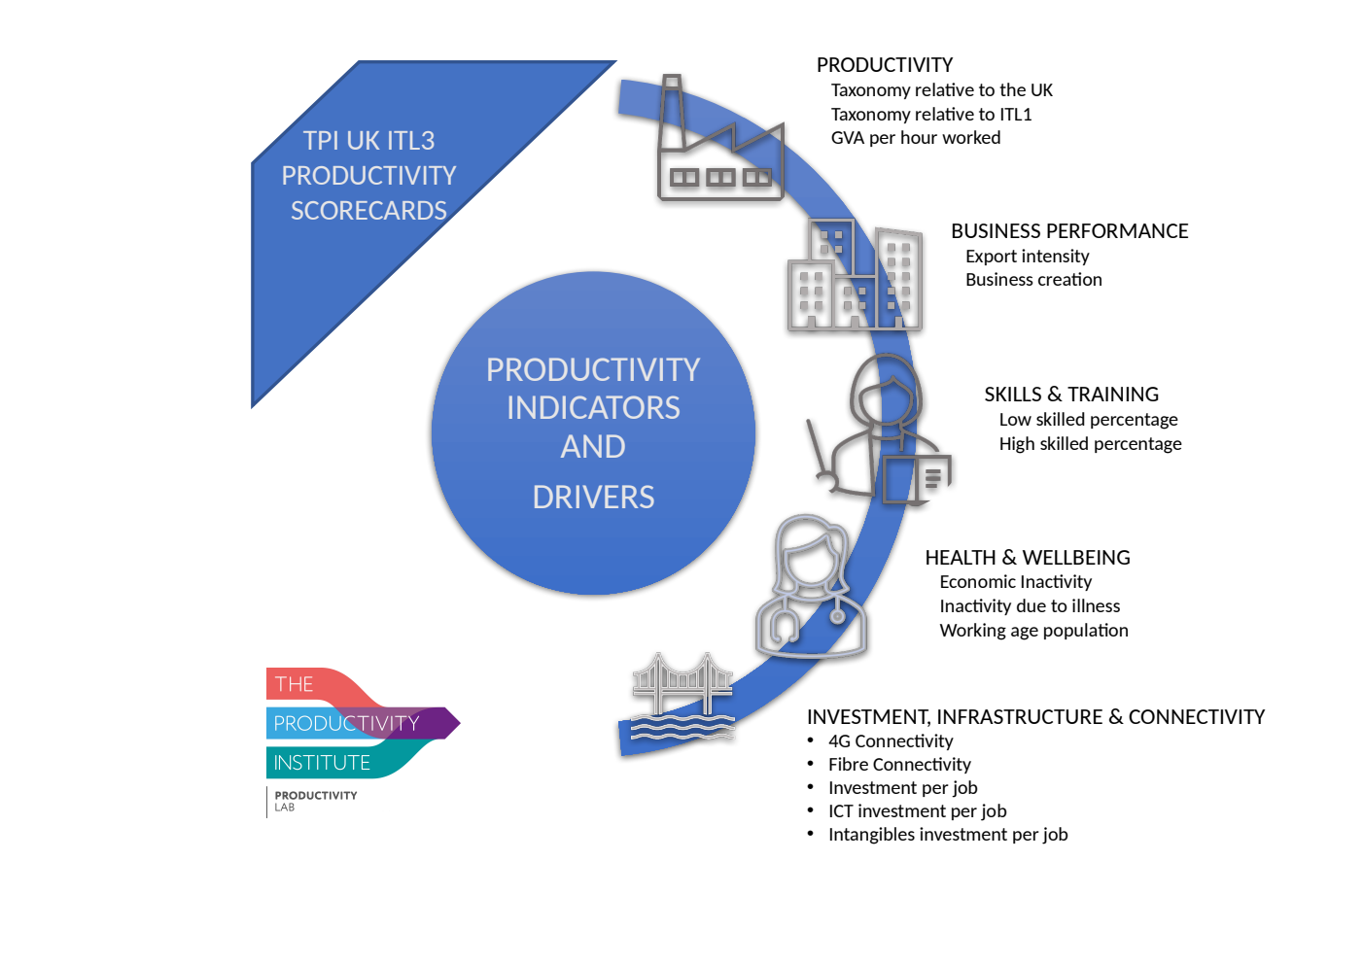

## Published Formats

The data for the TPI ITL3 scorecard indicators are published in two ways. Firstly, a bulk file in CSV format is provided, which can be used for statistical analysis of the indicators. Secondly, the scorecards are published in PDF files organised by ITL1 aggregate region, with annual tables for the productivity indicators and drivers by category for each of the ITL3 sub-regions. These tables are colour-coded to show the performance of each indicator relative to the regional **average** of the ITL1 parent region in that year. This deviates from the ITL1 scorecards, which compare productivity drivers against the UK **median** of the ITL1 regions. For some indicators, data is not available at the most detailed ITL3 level, while data for the higher geographical aggregate (ITL1) region are. We include all available information for calculating the aggregate ITL1 average to provide the best reference for comparisons of the underlying ITL3 regions. Blank cells indicate that the data is not available.

The colour codes indicate whether the ITL3 region is performing better (green), worse (red), or equal to the ITL1 regional value (orange). Green indicates performance higher than 105% of the ITL1 average. Orange shows a value of a productivity driver between 95% and 105% of the ITL1 average. Red indicates performance lower than 95% of the ITL1 average.

## Data Sources

For the compilation of the ITL3 scorecards, data is taken from several sources and is harmonised into a consistent format. While most of the information on the indicators and drivers of productivity could be obtained from a single source for all regions, the Labour Force Survey data for Northern Ireland had to be collected from the Northern Ireland Statistics and Research Agency (NISRA).

Unfortunately, for many of the data sources, there is little consistency in the published data formats, even when data is collected from the same source. This is a problem when the layout of spreadsheets changes between annual publications, particularly when indicators are denoted as numbers in one year but as text in the next or when regional codes have been redefined over time. Therefore, extensive efforts have been dedicated to data cleaning, harmonising data formats across time and space, creating uniform mapping tables for generating ITL3 aggregations, and thoroughly checking the results for consistency. Consequently, although the source data remains accessible from the original sources, we also provide the raw data aggregated to the ITL3 geographical level, which served as the foundation for deriving the indicators. This supplementary research data is available in CSV format for analytical use. When using these data, references should be made to the original data sources providers.

The Data Sources Overview table below presents the sources for each indicator, along with information on the specific release of the data set and the geographical level at which the data is available from the source. The following section describes, for each category, how the indicators are calculated from the source data.

Data Sources Overview table

|  |  |  |  |
| --- | --- | --- | --- |
| Category | Indicator / Driver | Sources | Geographical level |
| Productivity | Taxonomy relative to the UK | [ONS Subregional productivity](https://www.ons.gov.uk/employmentandlabourmarket/peopleinwork/labourproductivity/datasets/subregionalproductivitylabourproductivitygvaperhourworkedandgvaperfilledjobindicesbyuknuts2andnuts3subregions); June 2024 Release | National level, ITL 1, 2 and 3 |
| Taxonomy relative to the ITL1 region |
| Gross Value Added (GVA) per hour worked. |
| Business Performance | Export Intensity | [ONS Subnational Tade in Goods](https://www.ons.gov.uk/businessindustryandtrade/internationaltrade/datasets/subnationaltradeingoods); June 2023 Release  [ONS Subnational Trade in Services](https://www.ons.gov.uk/businessindustryandtrade/internationaltrade/datasets/subnationaltradeinservices); June 2023 Release  [ONS Regional gross domestic product: all ITL regions](https://www.ons.gov.uk/economy/grossdomesticproductgdp/datasets/regionalgrossdomesticproductallnutslevelregions); April 2024 Release | National level, ITL 1, 2 and 3 |
| New Businesses | [ONS Business demography, UK](https://www.ons.gov.uk/businessindustryandtrade/business/activitysizeandlocation/datasets/businessdemographyreferencetable); [November 2023 Release](https://geoportal.statistics.gov.uk/documents/ons::local-authority-districts-counties-and-unitary-authorities-april-2021-map-in-united-kingdom--1/about) | [District, Counties And Unitary Authorities Within Region And Country](https://geoportal.statistics.gov.uk/documents/ons::local-authority-districts-counties-and-unitary-authorities-december-2022-map-in-the-uk/explore) |
| Skills & Training | Low Skilled | [ONS Annual Labour Force Survey](https://www.nomisweb.co.uk/datasets/apsnew); January 2023 latest revision  [NISRA Labour Force Survey Tables for Local Government Districts 2009-2022](https://www.nisra.gov.uk/publications/labour-force-survey-tables-local-government-districts-2009-2022); October 2023 Release  [NISRA Highest qualification level and participation in education and training 2022](https://www.nisra.gov.uk/publications/labour-force-survey-tables-local-government-districts-2009-2022); December 2023 Release  [NISRA Reasons for Economic Inactivity by Local Government Districts, 2014 to 2022;](https://urldefense.com/v3/__https:/www.nisra.gov.uk/system/files/statistics/TblLFS2300.XLSX__;!!PDiH4ENfjr2_Jw!DHz13kWGCm2Qk3uTmAQIgwUwTRfg_J9lbT44B5ygbDsOmpxqQ1gHnmCClsPTd-pKKO5C_HB61Om_vrRTRYUY6A_tvmx6qw$) December 2023 Release  [ONS Regional gross domestic product: all ITL regions](https://www.ons.gov.uk/economy/grossdomesticproductgdp/datasets/regionalgrossdomesticproductallnutslevelregions); April 2024 Release | LFS data downloaded at NUTS 1 and 3 level  Northern Ireland data available from NISRA at the ITL3 level |
| High Skilled |
| Health & Well-being | Active population |
| Inactive due to illness |
| Working Age |
| Investment, Infrastructure & Connectivity | 4G connected | [Ofcom Connected Nations](https://www.ofcom.org.uk/research-and-data/multi-sector-research/infrastructure-research); September Releases for [2020](https://www.ofcom.org.uk/research-and-data/multi-sector-research/infrastructure-research/connected-nations-2020/data-downloads), [2021](https://www.ofcom.org.uk/research-and-data/multi-sector-research/infrastructure-research/connected-nations-2021/data-downloads) and [2022](https://www.ofcom.org.uk/phones-and-broadband/coverage-and-speeds/data/).  Data downloaded on Mobile and Fixed coverage | Local and unitary authority |
| Fiber connected |
| GFCF per job | [ONS Experimental regional gross fixed capital formation (GFCF) estimates by asset type](https://www.ons.gov.uk/economy/regionalaccounts/grossdisposablehouseholdincome/datasets/experimentalregionalgrossfixedcapitalformationgfcfestimatesbyassettype); May 2022 Release | National level, ITL 1, 2 and 3 |
| ICT per job |
| Intangibles per job |

## Methodology

The productivity indicators and drivers at the ITL3 level have been derived from the data sources referenced in the overview table. This section explains in detail how the source data was used to calculate the indicators for each category.

### Productivity

This category shows 3 indicators which gauge the relative performance of labour productivity across the ITL3 regions, comparing it to other ITL3 regions, the ITL1 parent region, and the UK as a whole. These indicators take into account both the level of labour productivity in the current year and productivity growth for the period from 2008 up to the current year. The data for this category stems from the ONS Subregional productivity data set, released in June 2023.

#### Taxonomy relative to the UK[3]:

This indicator of productivity reflects how well the ITL3 region is doing in terms of its productivity performance relative to the UK national average. This is measured along two dimensions. First, labour productivity in the current scorecard year, measured as Gross Value Added (GVA) per hour worked, is compared to that of the UK average. Second, the growth in productivity from 2008 up to the current year (corrected for price changes) is compared to that of the UK average. By comparing the region’s productivity along these two dimensions, a Taxonomy of relative productivity performance can be constructed as follows:

* **Falling behind:** Both the region’s current year productivity and its productivity growth are below the UK average.
* **Catching up:** The region’s current year productivity is below the UK average, but its productivity growth is above the UK average.
* **Losing ground:** The region’s current year productivity is above the UK average, but its productivity growth is below the UK average.
* **Steaming ahead:** Both the region’s current year productivity and its productivity growth are above the UK average.

#### Taxonomy relative to the ITL1 region:

This indicator of productivity reflects how well the ITL3 region is doing in terms of its productivity performance relative to the average of the ITL1 parent region. The taxonomy is determined using the same methodology as above.

#### Gross Value Added per hour worked:

This is the standard indicator of labour productivity, measured as output per unit of labour, where output is measured as Gross Value Added, and the unit of labour is an hour worked.

### Business performance

This category illustrates Business performance as a driving force of regional productivity. The literature extensively considers business export activity and its dynamicity as the two most important determinants of business performance in a given location. Understanding the dynamics of export activities is essential, as they play a significant role in shaping not only the economic landscape but also the competitive edge of businesses operating in that area.

#### Export Intensity:

Regional export intensity is an important productivity driver since firms competing in international markets tend to increase their productivity through process efficiencies and cost reduction, and therefore, higher export performance by local firms leads to higher regional productivity. It is calculated by adding the nominal values of trade in goods and of trade in services and dividing by the ITL region’s nominal value of GDP. Subnational trade and GDP data are taken from ONS and available at the ITL3 geographical level. Since this metric is constructed from separate estimates of exports in goods and services, confidentiality issues can arise at the detailed ITL3 regional level, resulting in missing values in the data set. This indicator uses the same data as the previous scorecard edition, as no new release has been published.

#### New Businesses:

The rate at which new enterprises are being created indicates the level of entrepreneurial activity in the local economy. Entrepreneurship, firm dynamicity and firm creation have been reported by many studies as important drivers for regional productivity and local economic prosperity. The ONS data set on Business demography in the UK presents annual data on total active firms and new firms in the UK by geographical areas, according to postal codes. These codes have been mapped to the ITL3 geographies, and the data has been aggregated according to this mapping. The data has been checked for consistency with reported totals at the ITL1 level. This driver of productivity is then calculated as the ratio of new firms over total active firms.

### Skills & Training

This category presents the composition of the local labour force as another key driver of regional productivity. These data are taken from the ONS annual Labour Force Survey (LFS) at the NUTS 1 and 3 levels, which relate directly to the corresponding ITL geographies. As data for Northern Ireland is not available from the ONS LFS, it has been obtained from the [Northern Ireland Statistics and Research Agency](https://www.nisra.gov.uk/) (NISRA), as presented in the overview table. The NVQ skill level definitions are available from [Gov.uk](https://www.gov.uk/what-different-qualification-levels-mean/list-of-qualification-levels). For 2022 data, NVQ levels have been replaced with RQF levels. These definitions are available [here](https://ofqual.blog.gov.uk/2015/10/01/explaining-the-rqf/).

#### Low Skilled

This driver of productivity presents the percentage of the working-age population (aged 16-64) with NVQ1(RQF1) or ‘no qualifications’. From the ONS LFS, data can be obtained on the number of workers with ‘no qualifications’, ‘NVQ1(RQF1)’ qualifications, and all working-age persons. The Low Skilled driver is calculated for each ITL3 region by adding the number of workers with ‘no qualifications’ and ‘NVQ1(RQF)’ qualifications and dividing by the working age population. For Northern Ireland, only the percentages of the workforce with NVQ2(RQF2)+ level, NVQ4+(RQF4+) level, and ‘No qualifications’ are available from two different data releases at the detailed ITL3 level. The Low Skilled regional population percentage has been calculated as a residual using the total working age population by ITL3 regions for Northern Ireland. For this driver, higher values inhibit rather than stimulate productivity. This is reflected in the scorecard tables by applying the colour scheme in reverse.

#### High Skilled

This driver presents the percentage of the working-age population (aged 16-64) with qualification at NVQ4+(RQF4+) level. We use the same sources and methodology as for the Low-Skilled indicator.

### Health & Well-being

This category reflects the impact of health and general wellbeing of people in the workforce on productivity. It is measured by the activity rates, illness rates, and the age composition of the working-age population. As with the data on Skills & Training, these data are collected from the ONS annual Labour Force Survey (LFS) at the NUTS 1 and 3 levels. Again, data for Northern Ireland is not available from the ONS LFS; it was obtained from the Northern Ireland Statistics and Research Agency (NISRA).

#### Active Population

Represents the percentage of the working-age population (aged 16-64) in the current year that were active in employment. It is calculated by dividing the number of workers active in employment by the total working-age population.

#### Inactive due to illness

Represents the percentage of the *inactive* working age population (aged 16-64) that were inactive due to ill health. Note that there is a small inconsistency in the definitions used by the ONS LFS, which uses the definition ‘Long-term sick’, and the NISRA LFS definitions, which uses ‘Health reasons’. For this driver, higher values inhibit rather than stimulate productivity. This is reflected in the scorecard tables by applying the colour scheme in reverse.

#### Working age

Represents the percentage of the total population of working age (aged 16-64) in the current year. Numbers for the population aged 16-64 are taken from the ONS and NISRA LFS data. However, neither the ONS or the NISRA LFS population data include residents under the age of 16. Therefore, total resident population numbers by ITL3 region were taken from the ONS data set on Regional gross domestic product to calculate the working-age population percentages for the ITL3 and ITL1 regions.

### Investment, Infrastructure & Connectivity

This category reflects the importance of investments in infrastructure for connectivity as a driver of productivity. The data for the years 2019, 2020, and 2021 are collected from the Ofcom Connected Nations and infrastructure reports. In addition, investments in machinery and equipment for production are a key factor in facilitating and strengthening productivity. Investments in intangible assets are also included in this category, as this covers organisational capital, such as management skills and patents, that can help improve productive capacity and overall efficiency. Data on regional investments is taken from the Experimental ONS data set on regional gross fixed capital formation by asset type. Unfortunately, this data set does not yet include data for the year 2021.

#### 4G connectivity

Represents the percentage of indoor premises with 4G services from all mobile network operators within the region. Mobile coverage information at local and unitary authority levels are collected from the four mobile network operators and analysed by Ofcom. For each area, we have multiplied the total number of premises in the region, also reported in the Ofcom data, by the percentage of premises that are 4G connected. We then aggregate both the resulting number of 4G connected premises and total premises by mapping the postal codes from the local and unitary authority level to their ITL3 aggregate regions. From these aggregated numbers, we recalculate the percentage of indoor premises with 4G services for the ITL3 regions.

#### Fibre connectivity

Represents the percentage of premises that have access to a full optic-fiber connection. It can be viewed as a measure of the availability of connectivity infrastructure. Similar to the 4G connected indicator, we aggregated the information on the total number of premises and the number of premises with a fibre connection to the ITL3 level and calculated the percentage for each ITL3 region.

#### Gross fixed capital formation per job

Another type of business investment is the total amount of investment in tangible and intangible assets, such as buildings, structures, roads, transport equipment, machinery, ICT equipment, and intellectual property products per job basis. The 2022 ONS data set on Experimental regional gross fixed capital formation (GFCF) estimates by asset typeprovides data for all ITL levels of geography. The number of jobs for each ITL region is taken from the ONS Subregional Productivity, June 2024 release. This indicator uses the same data as the previous scorecard edition, as no new release has been published.

#### ICT investment per job

Using the same sources as for the Gross fixed capital formation per job indicator, the ICT investment per job indicator measures the total amount of investment in ICT equipment per- job basis for the current scorecard year. This indicator uses the same data as the previous scorecard edition as no new release has been published.

#### Intangibles investment per job

Using the same sources as for the Gross fixed capital formation per job indicator, the Intangibles investment per job indicator measures the total amount of investment in intangible capital on a per-job basis for 2020. This indicator uses the same data as the previous scorecard edition as no new release has been published.

1. 1 Fatima Garcia is a Research Associate within TPI and a data consultant at The Data City; Olga Menukhin is a Research Associate with TPI at Alliance Manchester Business School ;Reitze Gouma is a Research Associate with The Productivity Institute (TPI) at the University of Manchester and the Database Manager and Administrator for the Groningen Growth and Development Centre at the University of Groningen; Raquel Ortega-Argilés is the director of the Productivity Laboratory at TPI, and Professor of Regional Economic Development at Alliance Manchester Business School; William Sarsfield is a Research Assistant with TPI at Alliance Manchester Business School; Ruby Watson is a Research Assistant with TPI at Alliance Manchester Business School.

   2Cite data set as: Garcia, Fatima; Gouma, Fokke Reitze; Menukhin, Olga; Ortega-Argiles, Raquel; Sarsfield, William and Watson, Ruby (2024). TPI UK ITL3 Scorecards, 2024 Edition. University of Manchester. Dataset. https://doi.org/10.48420/23791680
2.
3. 3The Taxonomy is based on: Zymek and Jones, 2020; [TPI, 2021](https://www.productivity.ac.uk/policy/)